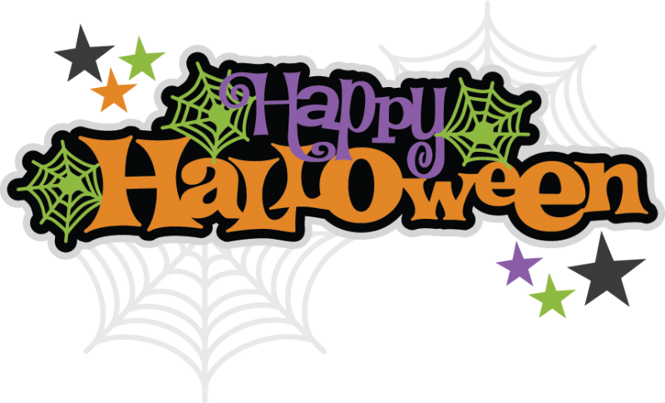

- - - - - - - - - - - - - - - - - - - - - - - - - - - - - - - - - - - - - - - - - - - - - - - - - - - - - - - - - - - - - - - - - - - - - - -

FREE ADMISSION FOR CHILDREN 12 & UNDER

When you come dressed in your Halloween costume and present this portion of the flyer at the door on Friday, October 31, 2014.

Valid one ticket per child per flyer

**Following the game, there will be a Trick or Treat, meet and greet, and autograph signing with the Springfield Jr. Blues!!!**

First Intermission Costume Contest, winner will receive a Jr. Blues Prize Pack.

**Join us on October 31 for Halloween with the Jr. Blues!!**